Overview

AnimPolish is a set of deformation tools that can be used on any polygon geometry in Maya 2015+, whether or not it's animated. Some of the tools can also be used on nurbs curves. The tools are intended to be used as a final step on finished animation. However, depending on your workflow, you may still be able to update animation after working in the polish step. Hover over any UI element to see summarized instructions about each tool.

The UI is divided into collapsible sections for each major tool. Under the General menu you can save your current view and option settings to be resumed when relaunched, though this feature is currently broken in Maya 2022 and newer. Under this same menu you can quickly toggle between parallel and DG evaluation. Parallel is encouraged unless you are using the Subdue tool, which is not compatible with parallel.

Installation

Installing AnimPolish is extremely simple since it does not use any plug-ins. This also means you can install at most studios and schools, as well as at home. To install, simply unzip the download and copy the animPolish directory into maya/scripts. The end result should be "maya/scripts/js_animPolish". The "maya" directory is usually found on your home drive or in "Documents" on Windows. On Mac OS it is usually found in Library/preferences/autodesk/maya/scripts.

In a fresh Maya session, copy/paste the following code into a Python tab of the script editor
and either run it or middle-mouse drag it to a shelf to make a button:

import animPolish.ui
try:
from importlib import reload
except:
pass
reload (animPolish.ui)
animPolish.ui.ui (dock = 1)

If you find that you see UI bugs such as double buttons, or simply prefer to launch undocked, change “dock = 1” to “dock = 0”.

Note on Shared Directories

Dear TD: If multiple users run this tool from a shared directory, you might want to fill in the
custom user_data_directory variable at the top of animPolish_ui.py. I'd recommend writing
some custom code above it to query the current user and concatenate a final path. If you don't,
the Save/Load Settings and Copy/Paste Attrs tools will end up overwriting each other between
users.

Contact

https://www.friggingawesome.com/support

Sculpt

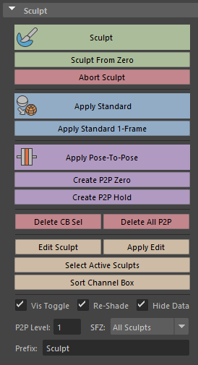

Select any polygonal meshes and hit Sculpt to begin to adjust the mesh using any Maya sculpting tools you like. This mesh will be deleted upon applying, so feel free to use any sloppy deformers on it you like, such as blendshapes. Sculpt From Zero enters sculpt mode after zeroing out sculpted deformation on the mesh, depending on the SFZ option.

Apply Standard creates a manually-keyable attribute for the sculpt. Apply Standard 1-Frame is the same, but keys 0-1-0 around the current frame.

Apply Pose-To-Pose creates a sculpt attribute that is keyed automatically between other pose-to-pose sculpts. Create P2P Zero creates a key within the P2P system with no sculpted deformation. Create P2P Hold holds the previous P2P sculpt to the current frame. P2P Level allows you to create P2P passes that only automatically key in and out of each other. It only works by increasing the level by 1 above the levels currently existing.

Wrap

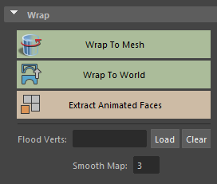

Wrap To Mesh wraps the first object in the selection wraps to the second, and includes a paintable wrap. Wrap To World simply creates a blendshape from a static duplicate of the object.

Fill the Flood Verts field with vertices of the mesh you intend to wrap to have them automatically flooded, and smoothed according to the adjacent field.

Extract animated faces duplicates selected faces with animation intact; useful for wrapping to just a few faces.

Subdue

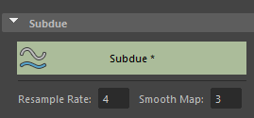

Average vertex animation over time, according to the Resample Rate. 3 means vertices get keyed every 3 frames and tweened inbetween, etc. Runs on full objects for selected vertices, and smooths around them if applicable. Supports object selection too. Requires DG evaluation mode to be enabled (General menu).

Grow/Shrink/Iron

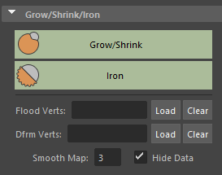

Grow/Shrink allows the mesh to grow or shrink along the vertex normals. Iron averages vertex positions. This mode can be slow, as it duplicates the entire selected mesh with input connections each time you run it.

For both tools, Flood Verts determines what vertices get automatically flooded to 1 and smoothed. Deform Verts determines what vertices the actual deformer is applied to. This can affect the result of Iron, but note that you will not be able to paint the blendshape resulting past the vertices you include.

Caching

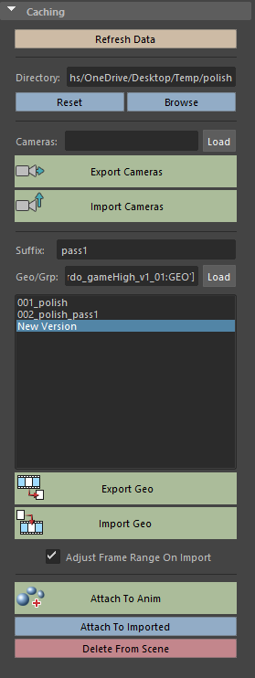

Hit Reset or Browse to create/load a polish directory to store caches for your scene.

Load your scene’s top-level camera nodes/groups to export cameras. Each polish directory can only store 1 camera export, therefore the Import Cameras button will always grab the one you export.

Load geometry, group, or groups into the Geo/Grp field. Export Geo will create a new cache if New Version is selected in the list of caches stored in your polish directory, or overwrite an existing one if it is selected. The Import Geo button imports the cache selected in the list.

When you import caches into a scene, they are stored under a polish_ABC_CTRL_GRP node in the outliner. Each imported cache ends in _ABC_CTRL. The bottom 3 buttons in the UI run based on _ABC_CTRL selection.

The Attach To Anim button will create blendshapes from all contained meshes under your _ABC_CTRL selection to the original meshes that created them, which were stored upon export. Attach To Imported allows you to blendshape the first _ABC_CTRL in your selection to the second. Delete From Scene deletes all relevant nodes.

